Part 1:

In the screenshot below I have created a function called print_volume. The function takes an argument for the radius and calculates the volume of the sphere which it prints out. I have passed the function 3 radius inputs and the outputs can be seen below.

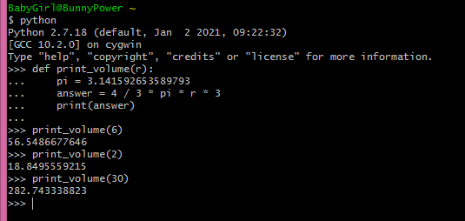

Part 2:

In the screenshot below I created a function called swap. The function takes one argument as input called twochars. The expected input is a string containing two character letters that the function will then swap around and print out.

Below you can see I put my function to the test with 3 values assigned to my input variable test. During the test I realized that my function only accounts for the first two characters in a given string and ignores all subsequent letters that follow. I also realised my function will not work with another data type as I get a data type error when using an integer as my parameter for input, indicating that the way I print out in my function using array allocation to print out a single letter at a time only works on string because a string is an array of characters and an integer is not, it is a single value even though it may contain two characters on the output screen when you look at it.

During this week I learnt how to define a function, how to assign variables both inside and outside a function, how to overwrite functions intentionally and also avoid overwriting them by accident, how to call functions, how to name things correctly and how to pass arguments to functions.

